A picture containing clipart

Description generated with very high confidence

NodeJS Module 7

Hands-on 1

[**support@intellipaat.com**](mailto:support@intellipaat.com)

**+91-7022374614**

**US: 1-800-216-8930 (Toll Free)**

**NodeJS Module 7**

**Hands-on 1**

**Install MongoDB**

**Step 1**: Open <https://www.mongodb.com> in a web browser

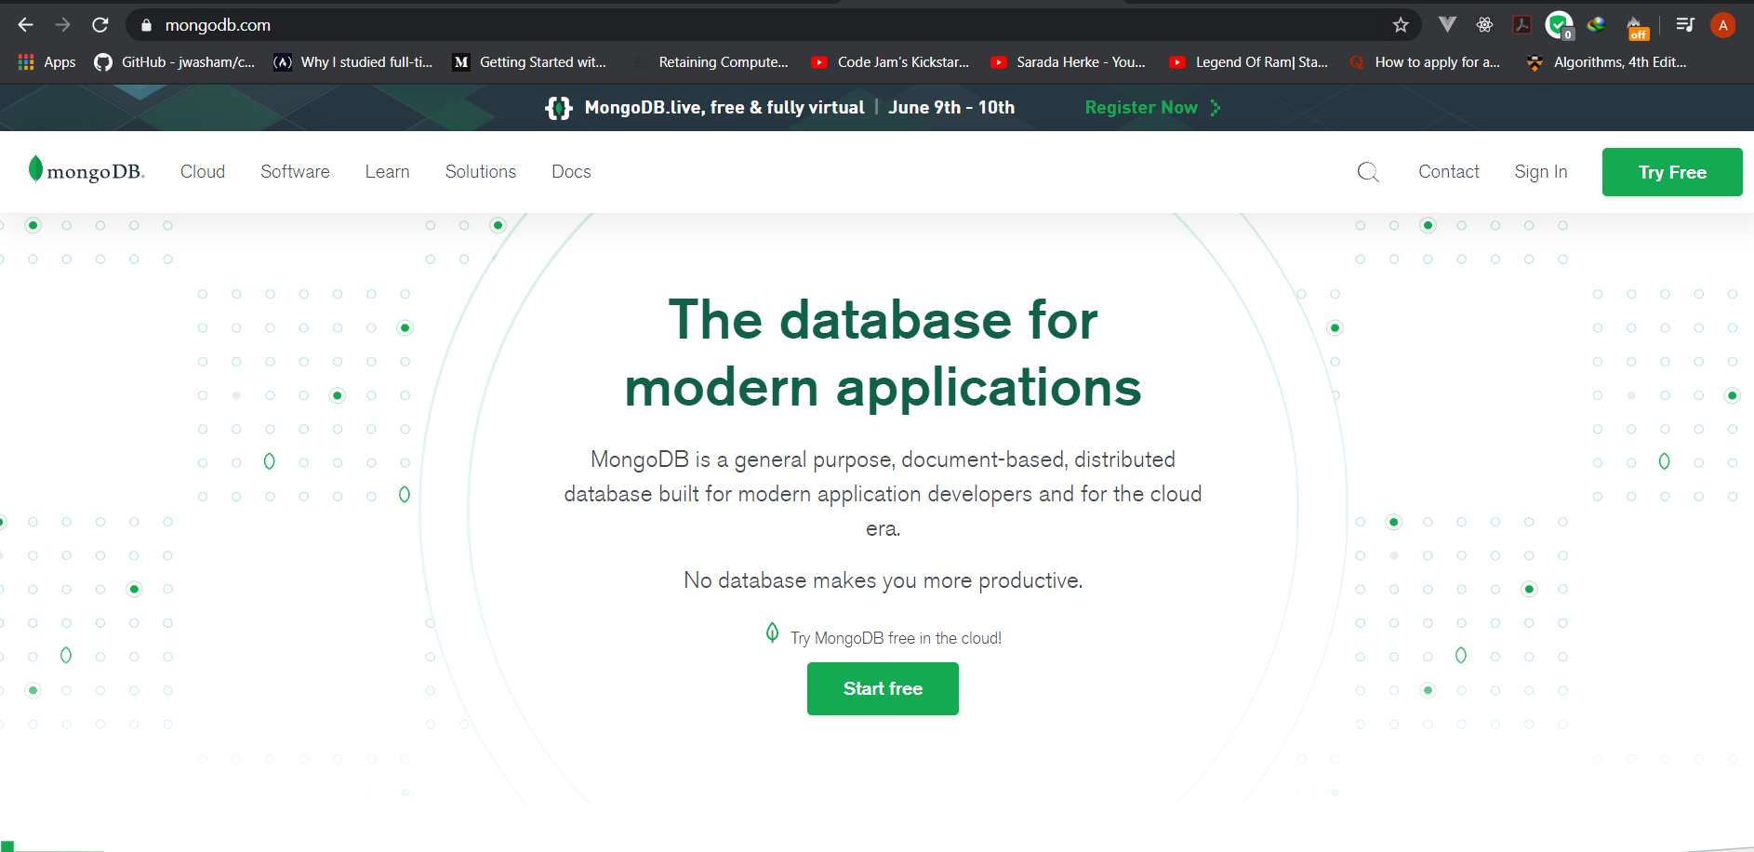

**Step 2**: Hover over Software and click on Community Server

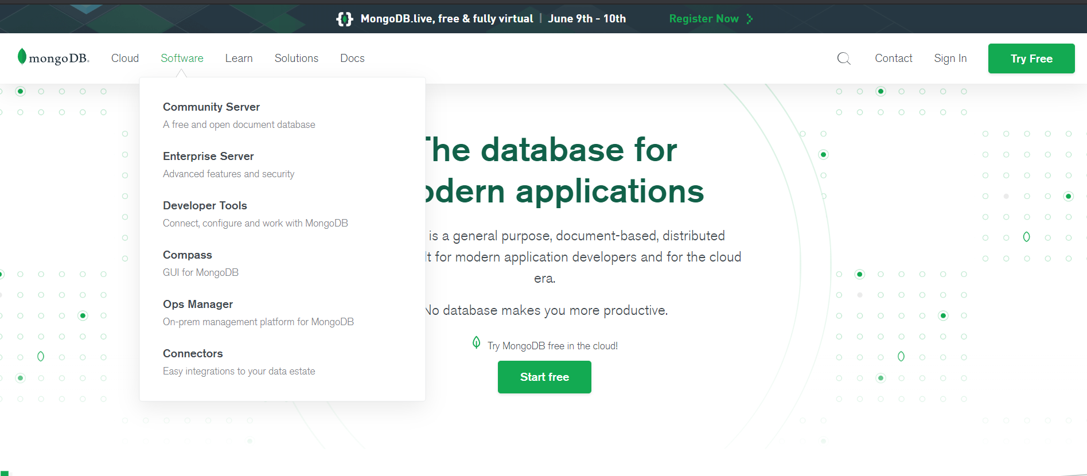

**Step 3**: Select the OS and click on Download

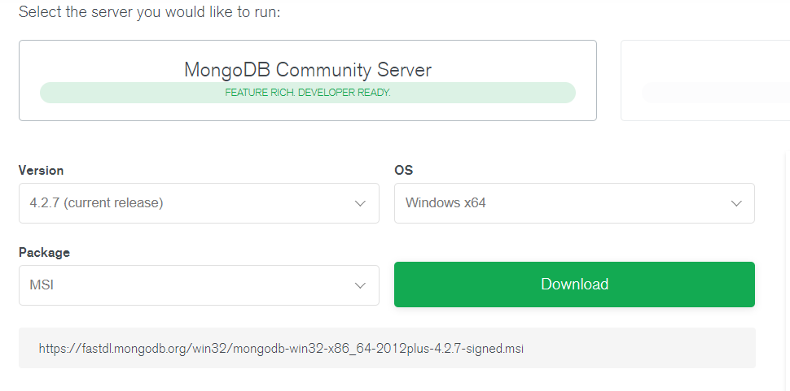

**Step 4**: Open the downloaded file and click on next

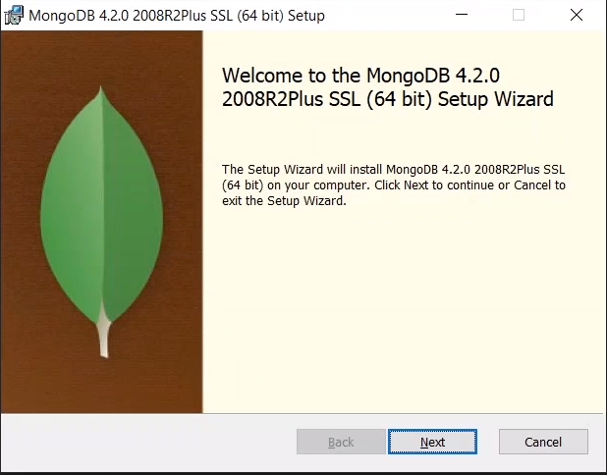

**Step 5**: Click on I accept checkbox and click on next

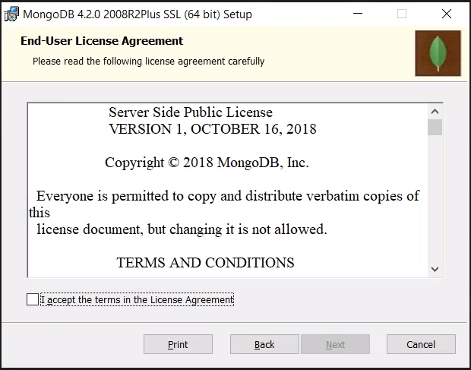

**Step 6**: Click on the Complete button:

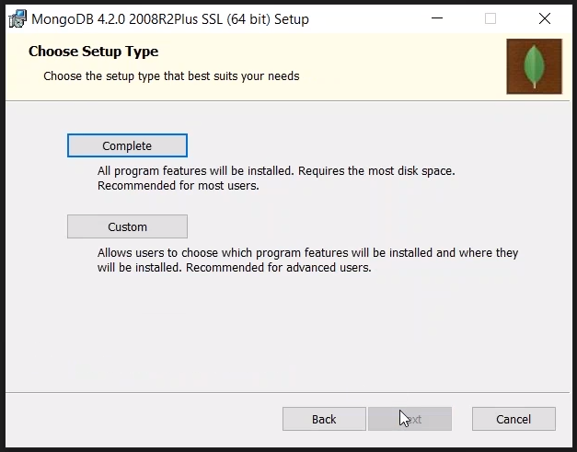

**Step 7**: Specify the installation Configurations and click on next

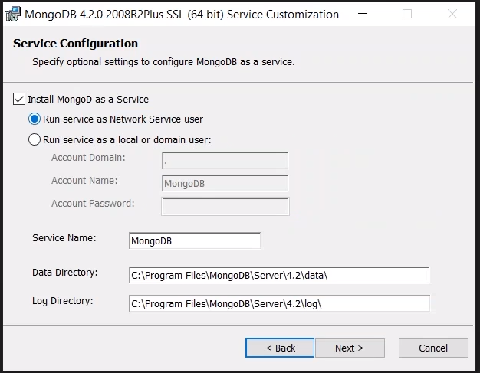

**Step 7**: Click on Install

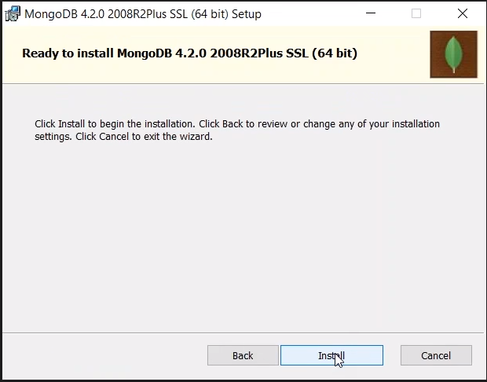

**Step 8**: Click on Finish

